SHORT BLURB – USLS PROMOTION
This short blurb can be used to promote the event to your students. You are welcome to edit the below content based on your communication platform. A number of universities promoting the event send a mass communication email to their students’ cohort.
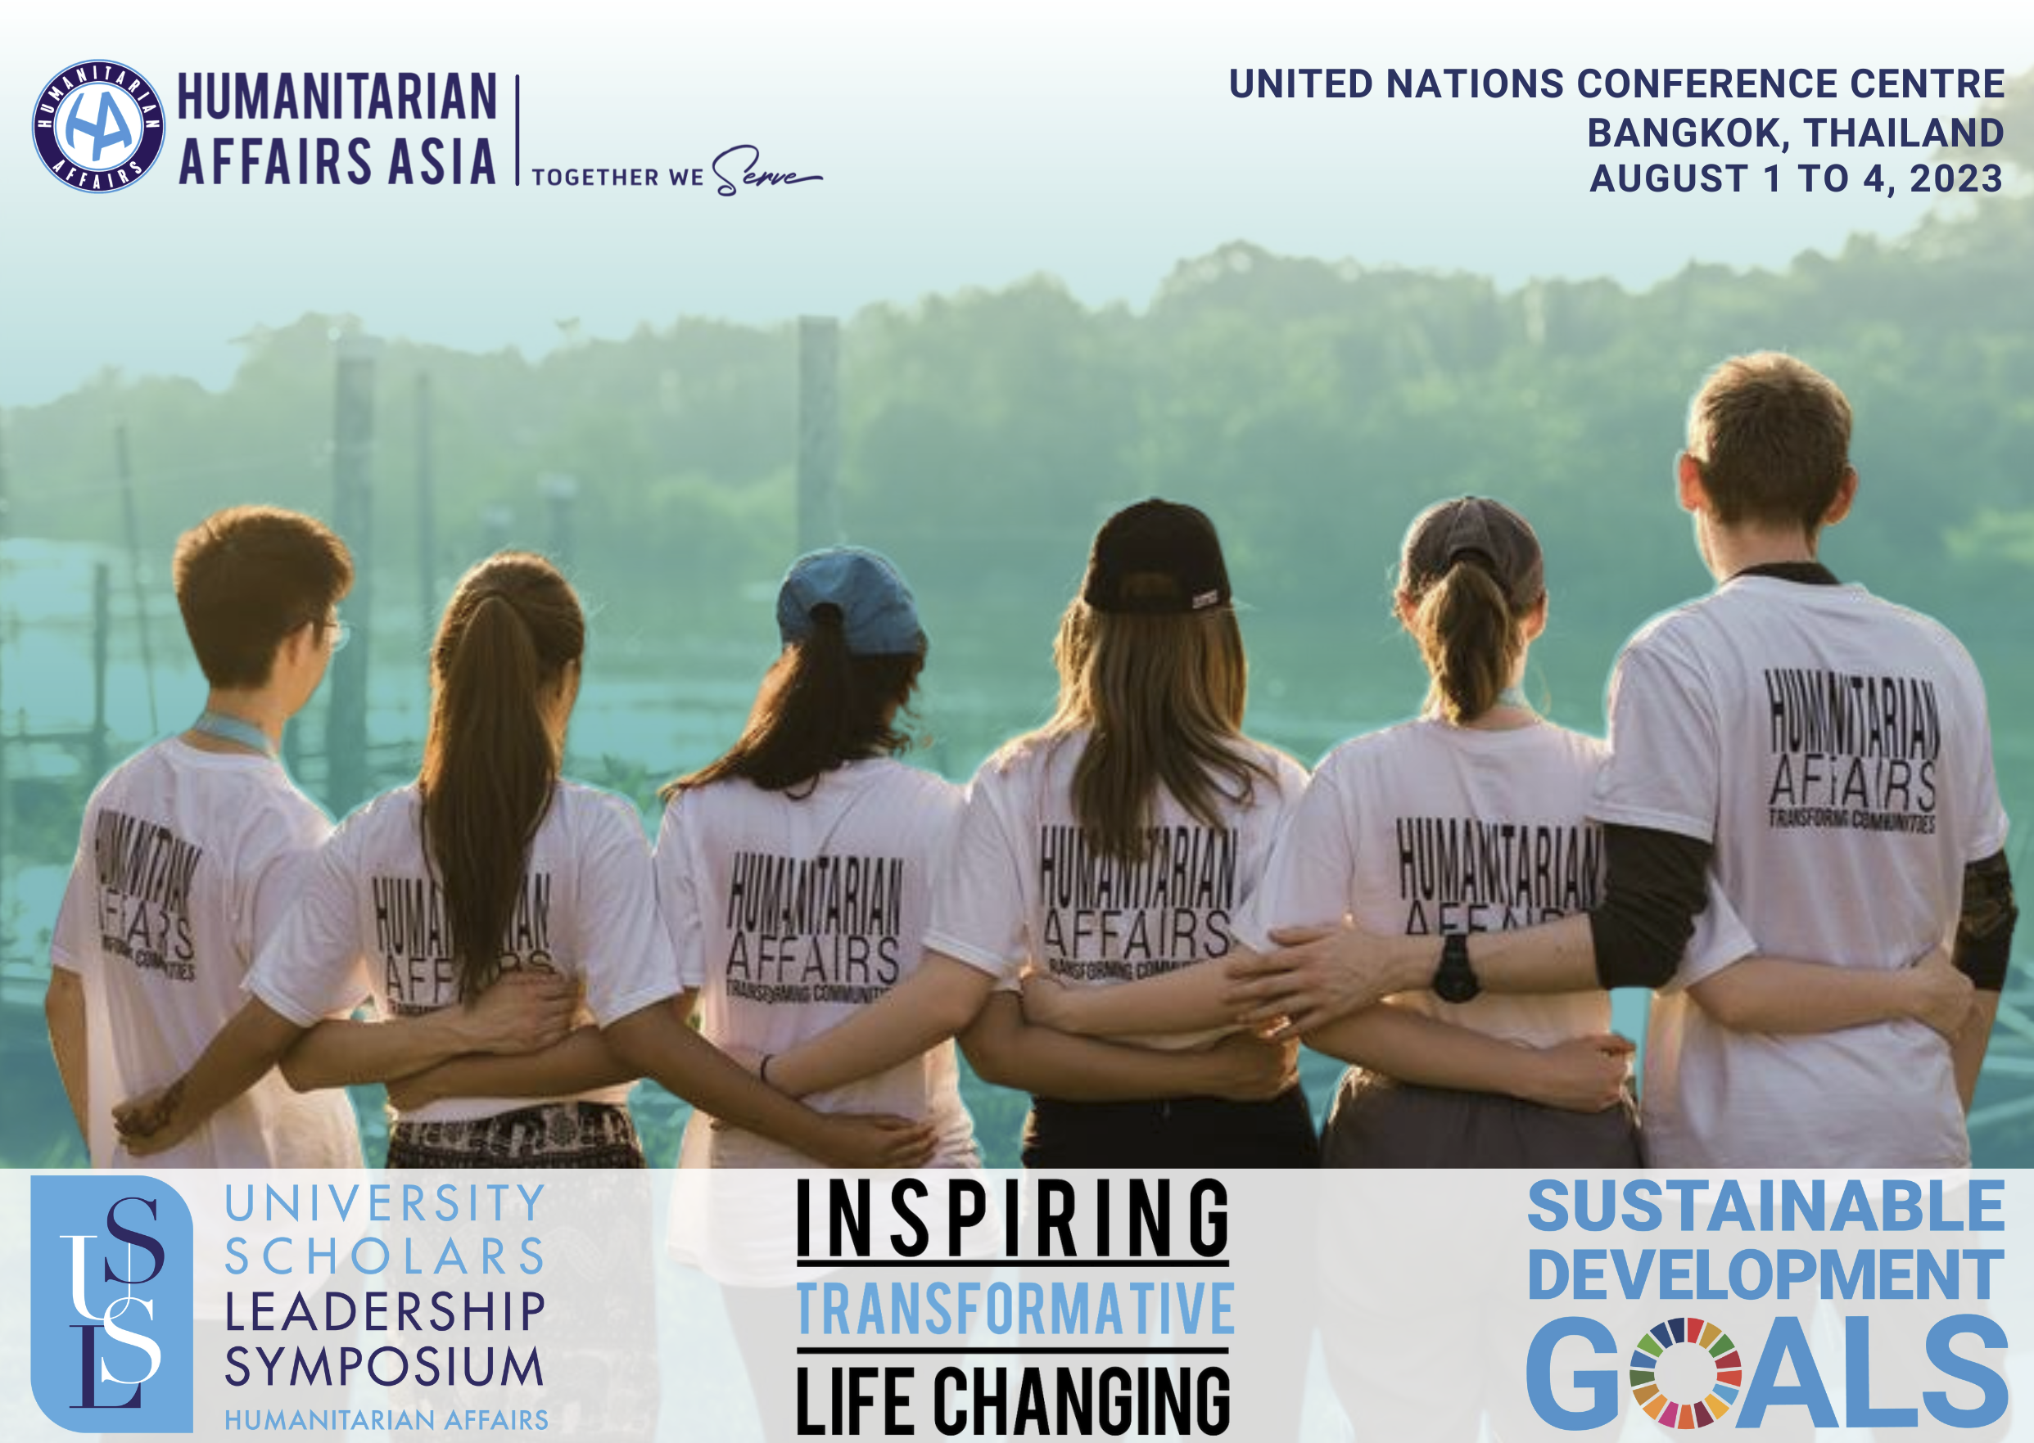
Do you want to do your part in realising a better future? Do you want to build a sustainable, inclusive, and humane world? Do you want to be part of something greater than yourself?
After a 3-year absence due to the Covid-19 pandemic, the much-awaited University Scholars Leadership Symposium (USLS) for outstanding student leaders has returned to the United Nations.
Humanitarian Affairs Asia is hosting the 11th USLS to gather outstanding young leaders from around the world who are passionate about social change. The summit will be held at the United Nations Conference Centre in Bangkok, Thailand from 1 to 4 August 2023.
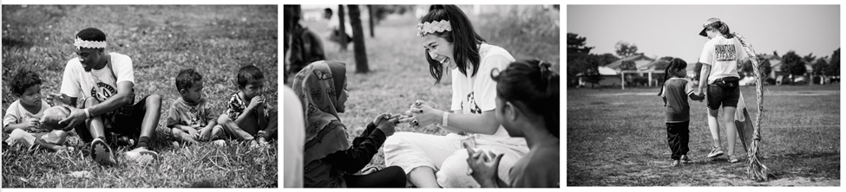
Approximately 1,200 emerging world leaders from over 100 United Nations Member States are expected at this prestigious youth leadership event, which focuses on developing leaders to bring about social change.
WHAT DOES THE USLS 2023 OFFER?
- INSPIRATION. Transformational talks with inspirational leaders and humanitarian heroes.
- OPPORTUNITY. Empowerment to initiate socially meaningful projects to address issues such as climate change, poverty, and inequality.
- NETWORKING. Global networking with like-minded peers committed to positive social change.
- PERSONAL DEVELOPMENT. Development of transferable skills, such as leadership and public speaking.
- CAREER ADVANCEMENT. Specially curated workshops by selected United Nations Agencies to learn more about advocacy work.
- VOLUNTEERING. Kindness Service Day of hands-on community activities.
- GLOBAL CITIZENSHIP. Become part of a global community of social changemakers.
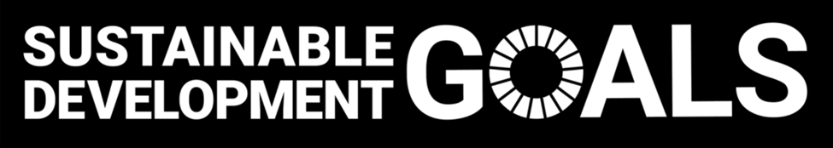
Please visit our website for more information about the program, speakers and registration fee. Click here for details about the registration fee.
Click here to watch one of the inspirational post event videos at the UN.
APPLY NOW. Write to Humanitarian Affairs Asia’s Lead Program Coordinator Riccardo Serbolonghi on riccardo.serbolonghi@humanitarianaffairs.org to request a copy of the Delegate Application Form.
If you need some fundraising ideas, you could write to us for a copy of our Sponsorships Guide.
Kindly note, students who apply by 30/04/2023 will receive the highest consideration to be admitted to the 11th USLS 2023.
USLS 2023 Brings the World Together as ONE!
CONTACT US
